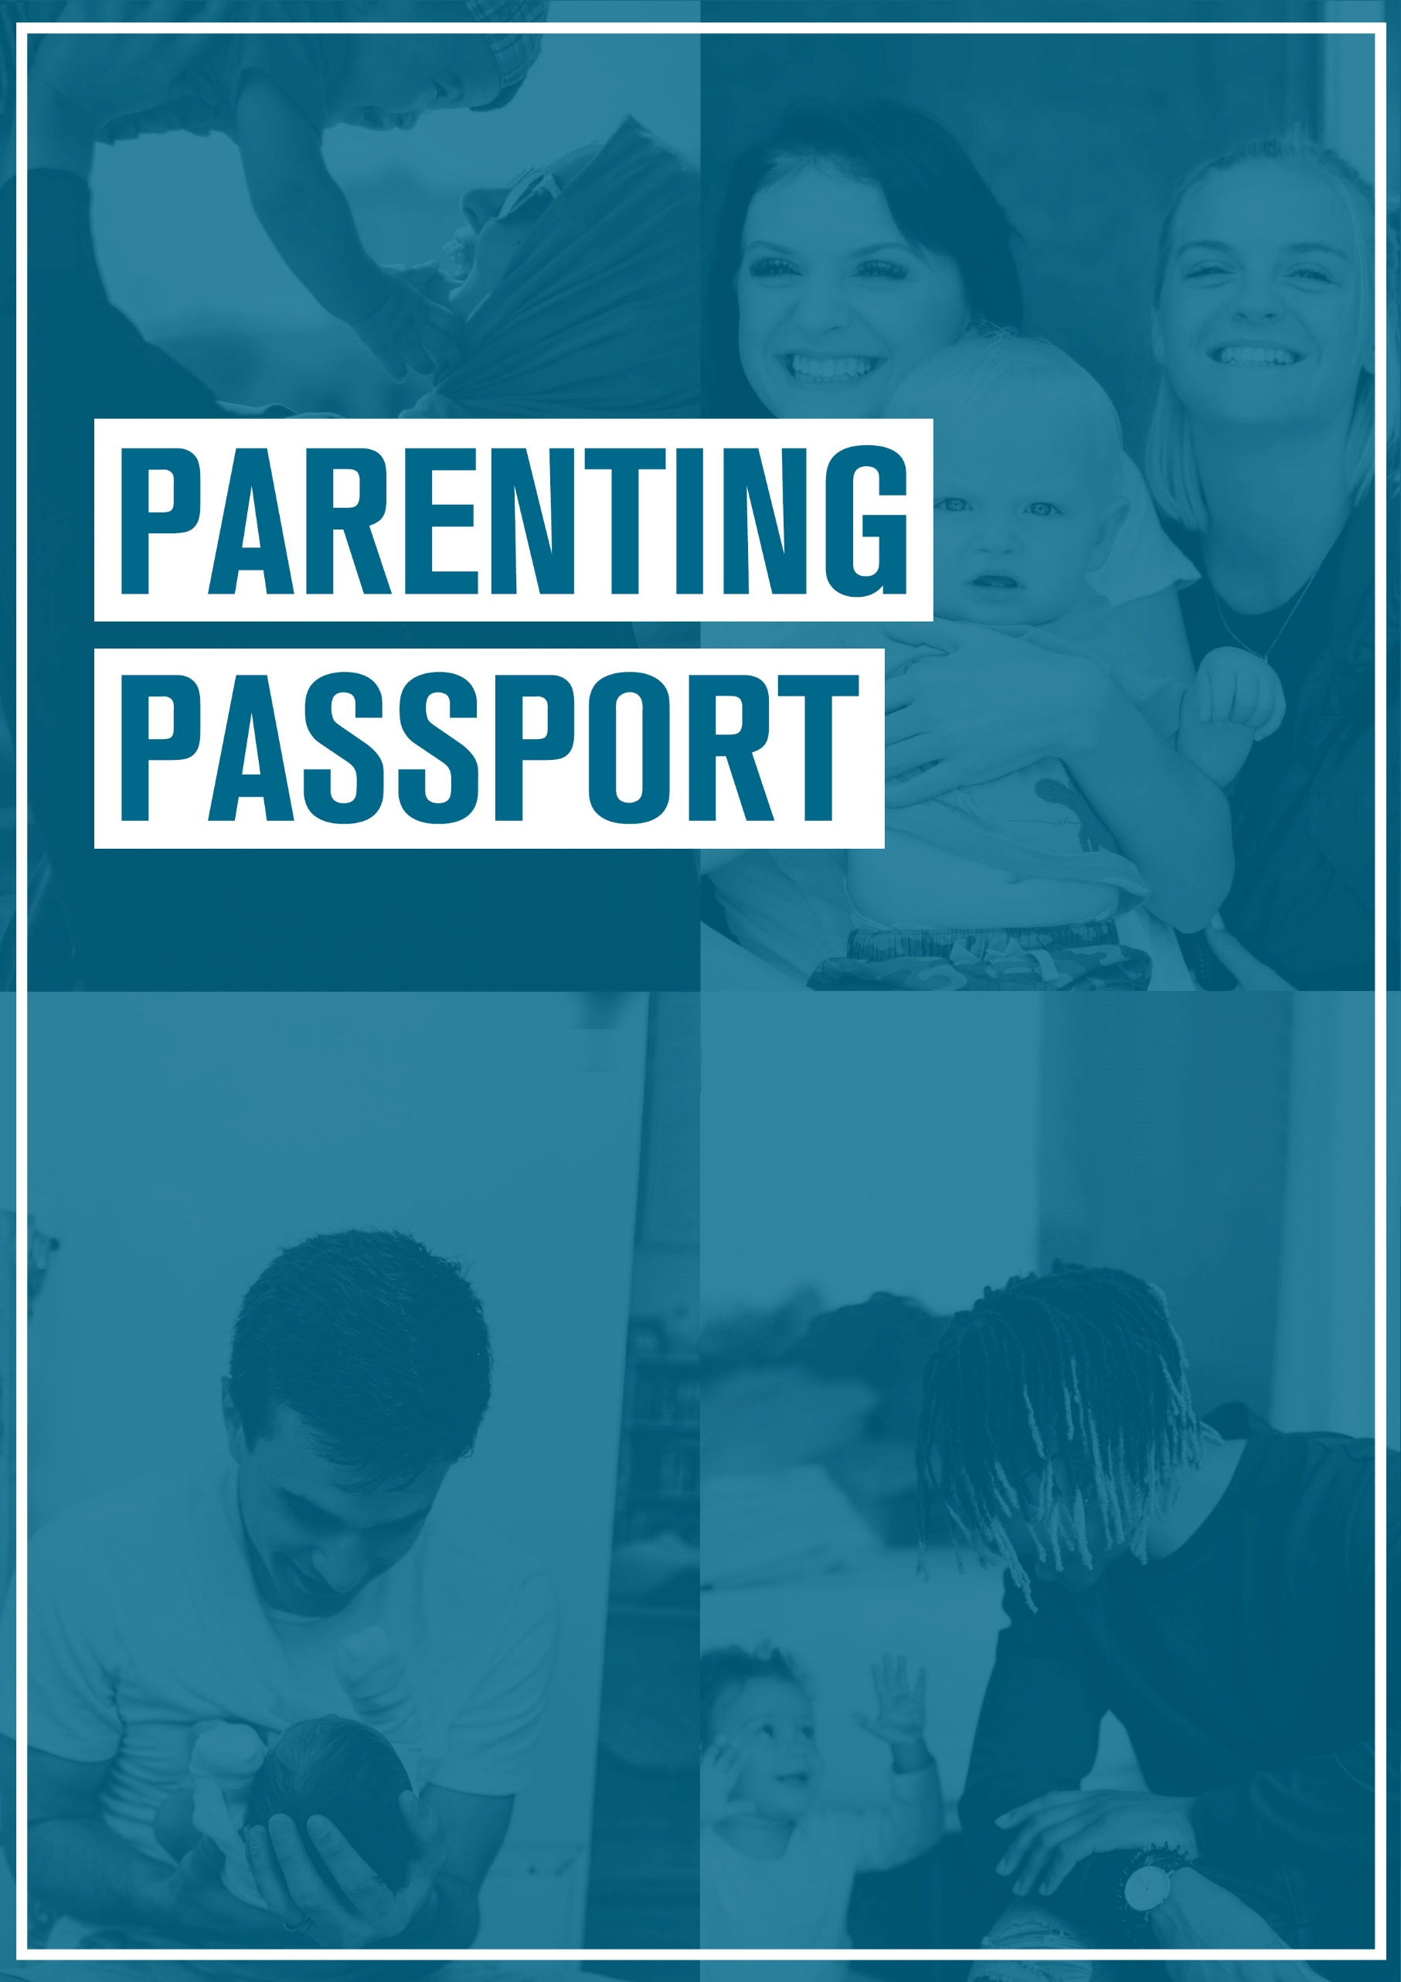
INSERT
COMPANY
LOGO
EMPLOYEE NAME:
MANAGER:
DATE:

USING THE PARENTING PASSPORT

A straightforward way to document flexibility and support so it can be carried into an employee's future roles.
The passport isn't just for new parents - it can be completed at any time, regardless of number of children, their age or other details. It can also be completed by prospective parents to discuss what possible support they may need in the future.
The passport is owned by the employee, but [employer to explain whether it should be logged centrally, such as with HR, in order to get consistency, or to be kept within the management structure].
The Parenting Passport assumes that you are working within parameters set by employment law along with any existing company policies. Therefore any flexible working arrangements are subject to discussion within the business.
Aspects of parenting are highly personal, and an employee should not need to disclose detailed information about their parenting role if they do not wish to. Everything discussed and recorded should be agreed with the employee, and holding a Parenting Passport is completely voluntary.

PARENT PROFILE
NAME:

DATE OF FIRST CONVERSATION:
LINE MANAGER:
ROLE IN ORGANISATION:

PARENTING ROLE (number of children, needs in terms of specific hours or other details):

IF YOU ARE EXPECTING A CHILD
WHAT SUPPORT DO YOU THINK YOU WILL NEED?
(Include childcare vouchers, flexible / reduced hours, etc)

SUPPORT PROFILE
SUPPORT CURRENTLY RECEIVING:
(Include childcare vouchers, flexible / reduced hours, etc)

SUPPORT DESIRED:
(What else would help?)

PARENTING AT [COMPANY]

HOW COULD [COMPANY] HELP WITH THE NEGATIVE ASPECTS THAT PARENTING AND WORK HAVE ON EACH OTHER IN YOUR LIFE?
(Are there any policies in place that could be made use of? Is there anything you would like to know more about? Are there any policies that could be improved?)
Employer to explain SPL and other family-friendly policies within the company

WHAT HAPPENS NEXT?
NEXT STEPS FOR THE ORGANISATION:
(Is there anything else that can be done? What are the next steps for the line manager to follow / escalate?)

NEXT STEPS FOR THE EMPLOYEE:

CONSENT AND STAYING IN TOUCH
☐ I am happy for my line manager / HR to keep a copy of this passport
☐ I am not happy for my line manager / HR to keep a copy of this passport*

NAME OF EMPLOYEE:
SIGNATURE:

NAME OF LINE MANAGER:
SIGNATURE:

DATE:

*If not shared with HR this information will not be passed to any new line manager.

